# Practical-6

**Name of Experiment: Binary to decimal conversation with seven segment display**

**Tools required: Logisim**

**Theory:**

The conversion of binary numbers to decimal format for output via seven-segment displays involves a systematic approach utilizing binary-to-decimal (BCD) conversion techniques. This process includes converting binary input into its decimal equivalent and then employing decoders to drive seven-segment displays, which visually represent the decimal numbers.

**1. Understanding Binary and Decimal Systems**

The binary number system, also known as base-2, uses only two digits: 0 and 1. Each binary digit (bit) represents a power of 2, depending on its position in the number. In contrast, the decimal number system (base-10) employs ten digits: 0 through 9. The need for conversion typically arises in digital systems, as raw data is often processed in binary but displayed in a human-readable decimal format.

**2. Steps in Binary to Decimal Conversion**

To convert a binary number to its decimal equivalent, each bit is multiplied by 2 raised to the power of its position, counting from right to left, starting at 0. The formula can be expressed as follows:

Decimal=𝑏

Where 𝑏 is the binary digit, and 𝑛 is the position of the digit. For instance, converting the binary number (1101)2 to decimal involves calculating as follows:

1⋅23+1⋅22+0⋅21+1⋅20=8+4+0+1=13

**3. Utilizing Seven-Segment Displays**

A seven-segment display consists of eight individual segments (seven segments plus a dot), which can be illuminated in different combinations to represent digits from 0 to 9. Each segment corresponds to a binary code. For example, if using a binary coded decimal (BCD) approach, a BCD to seven-segment decoder is employed to interpret the binary number and represent it visually on the display.

**4. BCD to Seven-Segment Decoder**

The BCD to seven-segment decoder, such as the TTL 74LS47 or 74LS48, takes a 4-bit binary input and converts it to a suitable format for the display. Each binary input combination corresponds to a specific output pattern that illuminates specific segments of the display to represent the appropriate decimal digit.

For example:

* Input (0000)2 outputs 0
* Input (0001)2 outputs 1
* Input (0010)2 outputs 2
* Input (1001)2 outputs 9

**5. Practical Application**

In a practical setup, a user can input a binary number using switches, which feeds into a binary to decimal converter circuit. The output from this circuit is fed into the BCD to seven-segment decoder, which drives the display to show the corresponding decimal value. The use of toggle switches allows manual input, while automated systems can read binary values directly from sensors or digital circuits.

**COMBINATIONAL ANALYSIS DAIGRAM:**

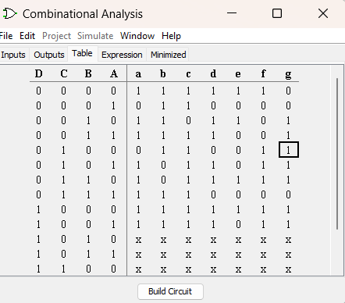

**Result:**



